Holy Ghost Byzantine Catholic Church
2310 South 24th Street
Philadelphia, Pennsylvania
19145-3207

Rectory: (732) 621-3823
Email: info@holyghostbyzantine.com
Website: https://holyghostbyzantine.com
Facebook: Holy Ghost Byzantine Catholic Church
Facebook (Choir): Holy Ghost Byzantine Church Choir

Father Vasyl Kopyn, Priest
Susan Krenicky & Andrew Yurick, Esq., Trustees
Dennis M. Donahue & Martha Dietz-Hanson, Cantors
Edward Danovich, Choir Director
Christopher Genzano, Administrator

Ccccccntdejfddekvhdbkhlddkcdfrcthrdjbnfucglr

Glory to Jesus Christ! Slava Isusu Christu!
Glory Forever! Slava Na Viki!
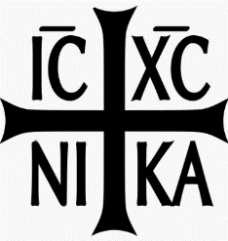
March 22, 2026

Schedule of Liturgical Services at Holy Ghost

Sunday, March 22nd: Fifth Sunday of the Great Fast (St. Mary of Egypt) Divine Liturgy: 9:00 am - Offered for +Helen Oslar by Jacklyn Donahue and Paul Meehan
Tone 8: page 161/231 Epistle: Hebrews 9:11-14, Gospel Mark 10:32-45

Wednesday, March 25th: Annunciation of the Theotokos
Divine Liturgy: 7:00 pm with Mirovanije

Friday, March 27th: Presanctified Liturgy, Sixth of the Lenten season
Presanctified Liturgy: 7:00 pm

Sunday, March 29th: Palm (Flowery) Sunday - Entrance into Jerusalem.
Divine Liturgy: 9:00 am - Choir and Distribution of Palms, Branches and Mirovanije
Palm Sunday: page 235 Epistle: Philippians 4:4-9, Gospel John 12:1-18

Friday, April 3rd: Holy Friday Service: 7:00 pm. Followed by All-Night Vigil

Sunday, April 5th: Pascha - *Choir* Feast of the Resurrection of Christ (Easter Sunday) with Mirovanije. Divine Liturgy 9:00 am
Pascha: page 164 Epistle: Acts 1:1-8 Gospel: John 1:1-17

For more information on the Liturgical Calendar visit the Metropolitan Cantor Institute’s website at: https://mci.archpitt.org/

Confessions - Fr. Vasyl is available after Liturgy every Sunday. For any Sacramental Emergencies or Funerals please contact Father Vasyl at (732) 621-3823.

Intentions for Sunday Divine Liturgies are being accepted for 2026. Please place an envelope with your intention in the collection basket at the back of church. The liturgical stipend is $20.

Bishop’s Appeal - is ongoing, to date Holy Ghost has contributed $5,275 to our goal of $7,800.00. If we meet our goal before June 30, 2026, we receive 40% of our donations directly back to the parish.

Candelabrum – During the week of March 22nd this is offered for +Michael and +Anna Dzamko by Nancy Licisyn & Family

Electronic Calendar - an electronic version of the Holy Ghost calendar, including liturgical and parish-life events for 2026, is now posted on our website.

Good Friday Vigil - after Vespers on Good Friday (April 3rd), we will offer All-Night Vigil. If you are interested, see the sign-in sheet in the Narthex.

Lenten Donation Drive - please donate new staples/toiletries and socks to the donation box in the stairway.

Parish Advisory Board - will meet after Liturgy on April 12th in the Lower Hall

Rosary will be recited at 8:30 am prior to each Sunday Liturgy and before every Holy Day.
Kindly remember in your prayers the members of our parish family who are confined to home, in a health care facility or in the hospital. May Our Lord, Physician of souls and bodies, extend His healing hand to ease their pain and suffering.
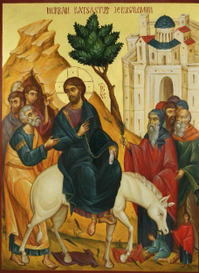

We begin our entry into Holy Week, welcoming the Lord on Palm Sunday

The icon for Palm Sunday is known as “Christ’s Triumphant Entry into Jerusalem” and recounts an event found in all four gospels. This icon is intended to depict the exultant welcome the Son of God received as He entered into His city and His kingdom. The arrival of the Messiah on the back of a donkey would have been bewildering to the Jews because a king entering a city on a horse meant war; a king arriving on a donkey meant peace.
(Next distribution April 5th)
Any special announcements will be published through e-mail list/social media and on our website between distributions.

